RHYTHMIC REFLECTIONS: A SYMPHONY OF EMOTIONS BASED ON FACIAL EXPRESSIONS



*Submitted in partial fulfillment of the requirements for the degree of*

**BACHELOR OF TECHNOLOGY**

**in**

# Computer Science and Engineering

# *by*

# 

**GADDI YASHWANTH**

**20K91A0529**

**Under the guidance of**

**Mr. SRIKANTH B**

**ASSISTANT PROFESSOR**

DEPARTMENT OF COMPUTER SCIENCE AND ENGINEERING TKR COLLEGE OF ENGINEERING AND TECHNOLOGY (AUTONOMOUS)

(Accredited By NBA and NAAC with ’A+’ Grade)

**Medbowli, Meerpet, Balapur (M), Hyderabad-500097**

## DECLARATION BY THE CANDIDATE

I , Mr. **GADDI YASHWANTH** bearing Hall Ticket Number: **20K91A0549,** here by declare that the main project report titled **RHYTHMIC REFLECTIONS: A SYMPHONY OF EMOTIONS BASED ON FACIAL EXPRESSIONS** under the guidance of **Mr. SRIKANTH B**, **Assistant Professor** in Department of Computer Science and Engineering is submitted in partial fulfillment of the requirements for the award of the degree of Bachelor of Technology in Computer Science and Engineering.

Gaddi Yashwanth

20K91A0549

Place: Meerpet

Date: 18/04/2024

## CERTIFICATE

This is to certify that the main project report entitled **RHYTHMIC REFLECTIONS: A SYMPHONY OF EMOTIONS BASED ON FACIAL EXPRESSIONS**, being submitted by Mr. **GADDI YASHWANTH** bearing Hall Ticket Number: **20K91A0549** in partial fulfillment of requirements for the award of degree of Bachelor of Technology in Computer Science and Engineering, to the TKR College of Engineering and Technology is a record of bonafide work carried out by him/her under my guidance and supervision.

Guide HoD

(Mr. Srikanth B) (Dr.A. Suresh Rao)

Place: Meerpet

Date: 18/04/2024

## TABLE OF CONTENTS

**ABSTRACT** **i**

ACKNOWLEDGEMENT ii

LIST OF FIGURES iii

LIST OF TABLES iv

LIST OF SYMBOLS AND ABBREVIATIONS v

1. INTRODUCTION 1
   1. 1.1 Motivation 1
   2. 1.2 Problem definition 2
   3. 1.3 Limitations of existing system 2
   4. 1.4 Proposed system 2
   5. 1.5 Advantages of Proposed system 3
2. LITERATURE REVIEW 4
   1. 2.1 Review of Literature 4
3. REQUIREMENTS ANALYSIS 6
   1. 3.1 Functional Requirements 6
   2. 3.2 Non-Functional Requirements 6
4. DESIGN 8
   1. 4.1 Data Flow Diagram 8
   2. 4.2 UML Diagrams 9

4.2.1 Class Diagram 10

4.2.2 Use Case Diagram 11

4.2.3 Sequence Diagram 12

4.2.4 Activity Diagram 12

4.2.5 Collaboration Diagram 13

4.2.6 Component Diagram 13

4.2.7 Deployment Diagram 14

4.3 Algorithms 15

1. CODING 17
   1. 5.1 Pseudo Code 17
   2. 6 IMPLEMENTATION and RESULTS 22
   3. 6.1 Explanation of Key functions 22
   4. 6.2 Method of Implementation 23
   5. 6.2.1 Output Screens 26
   6. 6.2.2 Result Analysis 30

**7** **TESTING and VALIDATION** 31

* 1. 7.1 Design of Test Cases and Scenarios 31
  2. 7.2 Validation 32

**8** **CONCLUSION** **and FUTURE SCOPE** 34

8.1 Conclusion 34

8.2 Future Scope 34

REFERENCES 35

## ABSTRACT

## This application application showcases the innovative use of facial expressions to interact with and enjoy music , demonstrating cutting-edge technological methods in the realm of music engagement . However, of these options, just as may manually playing music and wearable computing devices, or using others to identify by auditory attributes that are essential to identify the existence of bird species. On the contrary, we suggest our system in the manual selection process and gameplay. Through those we used Convolutional Neural Network to recognize the emotions, we got the following. Pygame and Tkinter are employed to help users with the music recommendations process. The speed of our proposed approach is competitive and the total cost of the proposed system will be lower than the similar solutions. The system correctly detects the expression types from pre-defined sets such as anger, disgust, fear, happiness, sadness, or neutral expression. The inbuilt camera makes the expressions easily readable by documenting them. One of the biggest technological advancements is in emotion detection of the user from input facial pictures, for example, the user's level of happiness. It is faster in terms of "computational time" than the existing ones and can categorize five emotions such as “rage, repulsion, terror, joy, melancholy” expression. Through listening to music, we can easily identify songs, an option which would automatically generate playlists.

## *Keywords: Factial expressions, Emotion detection, Convolutional Neural Network (CNN).*

## ACKNOWLEDGEMENT

The satisfaction and euphoria that accompanies the successful completion of any task would be incomplete without the mention of the people who made it possible and whose

encouragement and guidance have crowned my efforts with success.

I am indebted to the Internal Guide, **Mr. Srikanth B**, Assistant Professor, Dept. of Computer Science and Engineering, TKR College of Engineering and Technology, for his support and guidance throughout my Thesis/Dissertation.

I am also indebted to the **Head of the Department**, **Dr. A. Suresh Rao**, Professor, Computer Science and Engineering, TKR College of Engineering and Technology, for his support and guidance throughout my Thesis/Dissertation.

I extend my deep sense of gratitude to the **Principal**, **Dr. D. V. Ravi Shankar**, TKR College of Engineering and Technology, for permitting me to undertake this Thesis/Dissertation.

Finally, I express my thanks to one and all that have helped me in successfully completing this Thesis/Dissertation. Furthermore, I would like to thank my family and friends for their moral support and encouragement

**GADDI YASHWANTH**

**20K91A0549**

Place: Meerpet

Date: 18/04/2024

## LIST OF FIGURES

|  |  |  |
| --- | --- | --- |
| **FIGURE NUMBER** | **FIGURE NAME** | **PAGE NO** |
| 4.1 | Data Flow Diagram | 8 |
| 4.2 | Class Diagram | 10 |
| 4.3 | Use Case Diagram | 11 |
| 4.4 | Sequence Diagram | 12 |
| 4.5 | Activity Diagram | 12 |
| 4.6 | Collaboration Diagram | 13 |
| 4.7 | Component Diagram | 14 |
| 4.8 | Deployment Diagram | 14 |
| 6.1 | Emotion Detection | 24 |
| 6.2 | Music Recommendation | 25 |
| 6.3 | Home Page | 26 |
| 6.4 | Music Playlist Page | 26 |
| 6.5 | Emotion Detection Home Page | 27 |
| 6.6 | Real Time Image Detection | 27 |
| 6.7 | Manual Image Detection | 28 |
| 6.8 | Manual Image Prediction | 28 |
| 6.9 | Graphical Visualization for Manual Image | 29 |
| 6.10 | Song Recommendation for Angry Emotion | 29 |
| 6.11 | Suggested Activities to Angry Emotion | 30 |

## LIST OF TABLES

|  |  |  |
| --- | --- | --- |
| **TABLE NUMBER** | **TABLE NAME** | **PAGE NO** |
| **7.1** | The Testing Results For Different Expressions | 32 |

## LIST OF ABBREVATIONS

## 

|  |  |  |
| --- | --- | --- |
| **S.NO** | **ABBREVATIONS** | **DEFINATION** |
| 1 | CNN | Convolutional Neural Network |
| 2 | SVM | Support Vector Machine |
| 3 | UML | Unified modeling language |
| 4 | LBP | Local Binary Pattern |
| 5 | RaFD | Radboud Faces Database |

**Chapter 1**

# INTRODUCTION

# Motivation

# 

In recent studies, numerous inquiries have delved into this topic, offering valuable insights and findings concluded that the brain is influenced in many ways by music, and the fact that people have a different reaction and response to music is an evident occurrence. A study explored the arguments about the reasons behind human perception of music; where it came out that music played an important function in managing arousal and mood. One of the two important roles music plays may be its ability to make people appreciate and be aware of their emotional/mental state and themselves. Music listening choices appear to be closely linked in people's psychology and emotions. The brain section in charge of the tempo, pitch, as well as the timber and mood of music integrates directly to those areas that regulate emotions and the mood. Individual intercourse is also an inescapable element of a person`s uniqueness. It is extremely truthful and expressive at the level of details and convey much info when seen via many forms such as body language, speech, facial expressions, or emotions. Nowadays smart is the new emotion sensor technology, that coves a huge range of applications like intellicards , security, surveillance, offenderscan , visualvault, pictureprobe , adaptive human-computer interfaces , and multimedia environments. As we see it, extracting the automatic features of the required emotion of multimedia items usually include such cases as music and movies and this system is becoming popular and it can play a significant role in many areas such as human-computer interaction and entertainment We suggest a recomnest for emosense tech based on facial expressions that can recognize emotions of user and suggest the relevant tunes. This system generates an appropriate playlist to the individual's mood series. It allows the user to divert his mind from a negative state to a more positive mood. If the emotion is positive, it will be a playlist that will be shown which have different kinds of music and those will turn the positive emotions into more positive mood. To illustrate emotion perception, we utilized the Kaggle Facial Expression Recognition dataset for emotion recognition. In order to analyze music, dataset of Bollywood Hindi song was created for the music player which has songs in different moods. To be accomplished by face emotion recognition which is carried out by more or less 95.14 percent accuracy by using CNN .

* 1. **Problem definition**

In traditional music players, a user had to actively scroll through the playlist and choose songs that would make him happy. Today, with ever-increasing advancements in multimedia and technology, various music players have been developed with features such as fast forward, reverse, variable playback speed, local playback, streaming playback with multicast streams, volume modulation, genre classification, and so on. These capabilities may meet the user's fundamental needs, but the user must actively go through the playlist of songs and select songs based on their current mood and behavior.That is an individual's demand; a user may occasionally feel the need and want to browse through his playlist based on his mood and emotions.

* 1. **Limitations of existing system**
* **Limited User Input:** present systems frequently require users to actively state their needs, that can be time-consuming and might not always capture the user's current mood.
* **Static Recommendations:** Genres and past listening habits might not reflect a user's current emotional state.You might be in the mood for something upbeat even if you typically listen to mellow music.
* **Accuracy Issues:** Genre classification and recommendation algorithms might not perfectly align with a user's actual taste.
  1. **Proposed System**

The new system is a music recommendation system which is emotion based and which utilizes face expression detection to show the user's mood and plays out the relevant music. The system is made up of three modules: facial-identification, emotion-classification and music recommendation. It uses a camera to track the users face, distill emotions, and then plays the music through a services provider via the internet. This aim of the technology is to develop more adapting and personalized music recommendations that are predicated on the user’s mood. Finally, the suggested method is made up of an interactive and responsive music recommendation process that gathers emotions directly by facial expression.

**Advantages of proposed system:**

1. By suggesting music according to the customer mood, it gives the user high pleasure. The tool dispenses with the need for additional sensors by employing camera in the user's mobile device to capture facial expressions.
2. The system will automatically pattern the user's keystrokes and mouse clicks with their selected music without using emotion as the judgeÂ as to what they like to listen to.
3. Music recommendation can be more precise and individual based simply by adding the user's emotional status at the moment of listening.

**Chapter 2**

# LITERATURE REVIEW

## 2.1 Review of Literature

We conducted the cross-database study [1] and found that raw features worked best for the RaFD (Radboud Faces Database) and Mobile Images dataset using Logistic Regression for testing. Utilizing the CK+ dataset as a training set, the accuracy increased to 66% and 36% separately. New features (distance and area) dropped the experiment's SVM (Support Vector Machine) measure of accuracy from 89%. The algorithm developed surpassed the SVM and some other algorithms in the respect of generalizing the training set results to the testing sets. For cross-validation=5, the RaFD database had a mean accuracy of 86%, and the CK+ database had a mean of 87%.The main target was to confect features and scrutinize the machine algorithm on the dataset.Nevertheless, the correct face-detection algorithms become vital in case there are many people in the image. One of the endeavor was performed [10] by pulling out the expression out from the live stream using the system's camera or any existing image in memory. It was written using Python 2.7, OpenCV, and NumPy. The task was to develop the mechanism that could determine the expression of a person only by analyzing a photograph. The study revealed that this method works efficiently and gives accurate results. Another topic that has been of interest is the Music Recommendation System. This [11] study took a straightforward approach to Hindi music mood assessment that relies on audio parameters.The MIREX (Music Information Retrieval Evaluation eXchange) mood taxonomy achieved an average accuracy of 51.56% utilizing 10-fold cross validation. Furthermore, according to an article [10], the present music suggestion research findings are based on the description of music resources. It is argued that present research lacks systematic research on user behaviour and demands, has a low level of feature extraction, and uses a single evaluation measure. Situation was discovered as a significant factor in the music tailored recommendation system. Finally, it was determined that assigning equal weights to all contextual factors significantly lowered the accuracy of the recommendation findings.An accuracy of 51.56% was achieved by the PIREX (Music Information Retrieval Evaluation eXchange) mood taxonomy on the basis of 10-fold validation. In addition, based on [10] journal article, the current music recommendation research studies are limited to the discussion of music resources description. The researchis not covering systematic user behavior and needs research and not taking feature extraction to a higher level as well as it is relying on a single evaluation measure. The discovery of the role of the user situation became a tricky part in the music personalized recommender system. Lastly we discovered that omitting all the weights of the contextual aspects led to poor accuracy of the recommendation findings. A system was constructed in such way that two softwares, Anaconda and Python 3.5 were used to test the functionality, along with two face identification techniques, Viola-Jones and Haar cascade. For the KDEF (Karolinska Directed Emotional Faces) dataset and VGG (Visual Geometry Group) 16 dataset, a CNN (Convolution Neural Network) model using an accuracy of 88% as performance measure has been tested and successfully executed. But the experiment exposed the fact that the produced network design is much more evolved than the preceding ones. The second system [9] deployed Python 2.7, OpenSource Computer Vision Library (OpenCV), CK (Cohn Kanade) and CK+ (Extended Cohn Kanade) databases with about 83% of the accuracy. There are some scholars who are of the opinion that the Extended Cohn-Kanade (CK+) database could be used as a tool for developing and testing face emotion detection algorithms. The fact that the popular and easily accessible first Cohn-Kanade dataset, is a great way to do that. Besides data collect, too, for a self-guided system to be stable under expression of a broad spectrum in actual conditions. For the purpose of achieving this goal, we need to combine the power of imagery visual codes that are highly accurate and uniform over a wide array of different images with an effort of collaborative research between the different institutions.

**Chapter 3**

# REQUIREMENTS ANALYSIS

# 3.1 Functional Requirements

# Each product has its own set of requirements that should be analyzed from the very first steps. These are known as requirements engineering (combination of two words: “requirements” and “engineering”). This function is dependent on ongoing interactions with product stakeholders and end-user, in order to clear up any grey areas, resolve issues and document all points of significance.User Interaction

* Data Processing
* System Functions
* Performance
* Security
* Integration
* Compliance
  1. **Non-Functional Requirements**

Nonfunctional requirements (NFRs) are concerned with the system properties of security, dependability, performance, maintainability, scalability, and usability. They are like inhibiting or limiting features of the system as it gets spread across varied aisles. Non-functional needs, also often known as system attributes, is as vital to detailing Epics, Capabilities, Features, and Stories as functional requirements are. They make sure that the proper use and the high performance of the system. The shortcoming in any of these can lead to system development which does not act as a solution to the internal company problems, user problems or even the market needs, as well as regulatory or standards agency requirements.

* Portability
* Performance
* Accuracy
* Maintainability
* Failure handling

**Chapter 4**

# DESIGN

# 4.1 DATA FLOW DIAGRAM:

• Data Flow Diagram (DFD) is one of the most essential modeling technique. It is used as components representation. These four interrelated components consists of the system process, data, an interactive external entity, and the information flow within the system.

• DFD identifies the sequence flows in the system and how the data changes during the process. The is a technique of visualizing the information flow and the changes that occur as data goes from input to output.

• The data flow diagram (DFD) is sometimes called bubble diagram. A DFD can be employed for describing a system at any degree of abstraction. DFD may be split into layers which reflect the increasing information in flow and functional aspects.

• Data flow diagrams are the representation of the data flow of a corporate information system. DFD explains the steps required to move data from the input to the file storage and print collected data from input to file storage and generate reports.

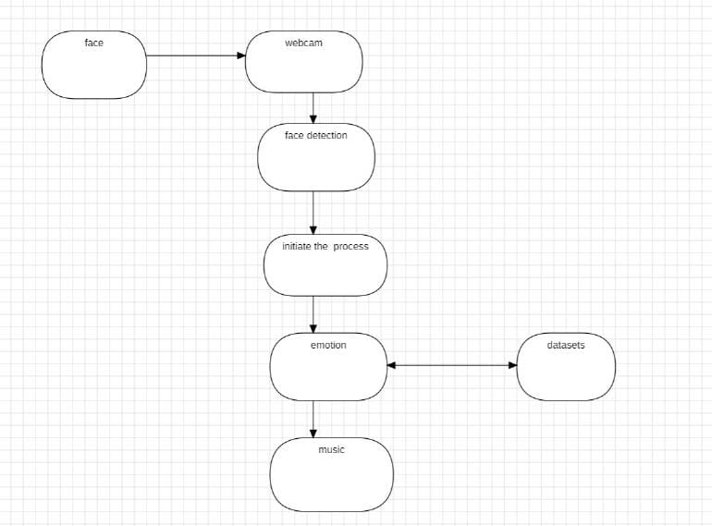

**Fig. 4.1** Data Flow Diagram

**4.2 UML DIAGRAMS**

UML is a standard language that is used to depict, outline, and document stages in the construction of the software systems. UML was produced by the Object Management Group (OMG) and UMI, with the version 1.0 specification submitted to the OMG in the beginning of 1997.OMG is constantly developing standards, one of which is to make the industry-wide standard.

UML is an abbreviation of Unified Modeling Language.

* UML is distinctive in that it is not a programming language like C++, Java, or COBOL.
* UML is a diagramming language with which software architectures are drawn.
* UML (Unified Modeling Language) is a graphical language that is mostly used for design, specification, building, and documentation of software systems.

Not only UML is used for modelling software systems, but it has a very wide range of applications as well. Also, it is used to model the systems that is not a software. Suppose we take as an example that of a manufacturer.UML is not a programming language, while it uses tools for creating code in different languages through UML diagrams. UML is an object-oriented analysis and design method used directly. At this point UML has been standardized by an OMG.

**Goals of UML:**

* A thousand words may be spent on describing UML, but a simple picture can do it just as well. As UML is an extension of the object-oriented principles emerging long before the actual object-oriented paradigm. In those days, there was no idea of how or what was an object-oriented programming which would lead to standardized process of programming. Then onward, by the use of UML (Unified Modelling Language) came into use. One of the primary purposes of designing UML, which may be the most noteworthy among them, is to develop a model that can be used by all modelers irrespective of their difference in skills. It should be however easy to be understood and applied as well.
* Therefore, UML diagrams are designed not only for the use of developers, but also everybody else even the ordinary people, business users, and basically anybody who wants to understand the system. It can be software one or hardware on the basis
* The main objectives of UML design are as follows:

1. Prepare a visual modeling language for the users in order to create and share relevant models.
2. Offer ways of extending key concepts and of specialization of them.
3. Stick to other programming languages and programming processes independently.
4. Establish the systematic structure for mastering modeling language.
5. Stress the growth of the OO tool trade market.
6. Enable development at a higher level which includes the development of collaborations, frameworks, patterns, and components.
7. Integrate best practices.

**4.2.1 Class Diagram**

Class diagrams classes.Interfaces, relationships, and collaboration. Class diagrams represent a static structure of the whole system and are the most commonly used diagrams of UML. Upon this class diagram are representations of an object-oriented system. The active class of a clas diagram will express system's concurrency. A class diagram indicates the object pool of a system in terms of orientation. So, it is most commonly used to cater for that particular need. It is considered the paramount of diagrams used while construction of the system is in process.

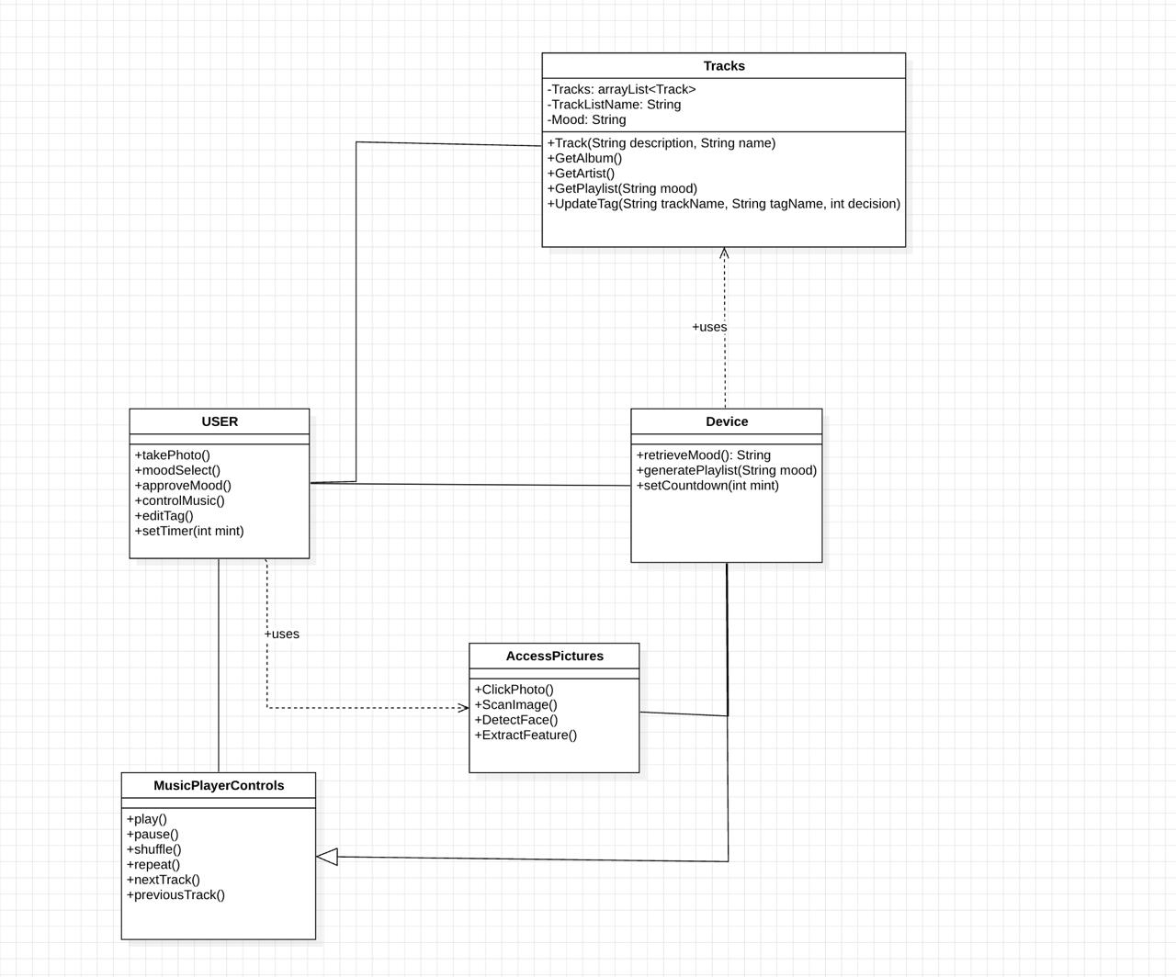

**Fig.4.2** Class Diagram

**4.2.2 Use Case Diagram**

The example of UML behavioral diagram, which is UML use case diagram, is a diagram evidenced and generated by a Use-Case study. Its main objective is visualizing the system as a whole by means of actors, objectives, and (dependencies that have been shown) via use cases. The main purpose of use-case diagram is to highlight the sequence of system functions in relation to who is performing them (actor). The actors playing different roles contributing to the system can be represented.

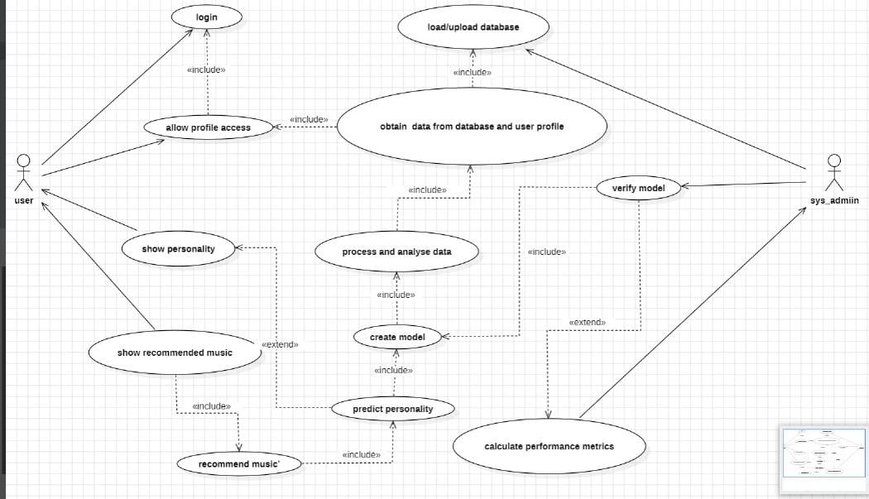

**Fig.4.3** Use Case Diagram

**4.2.3 Sequence Diagram**

Sequence diagram in the Unified Modeling Language (UML) is a form of interaction diagram that represents how processes interact with one another in what order. It is a part of a Message Sequence Chart. Sequence diagram is another name for event diagram, event situation and timing diagram.

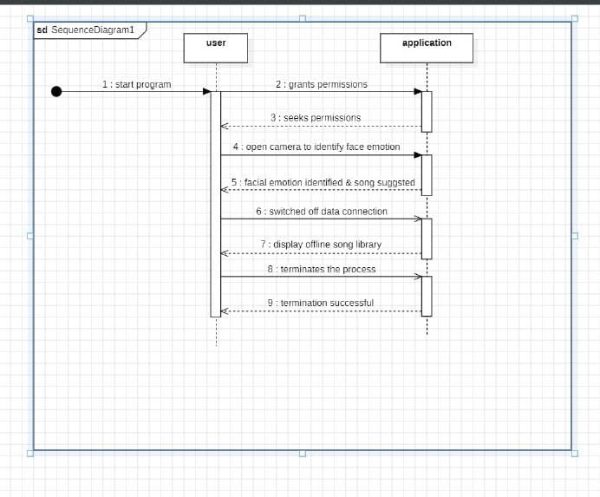

**Fig.4.4** Sequence Diagram

**4.2.4 Activity Diagram**

Activity diagrams are diagrams which show, graphically, a series of events and actions, which can provide for branching, looping, and actions happening simultaneously. Activity diagrams can be used to show the business flow and processes of system components in the Unified Modeling Language. What get depicted is the overall flow of control by an activity diagram.

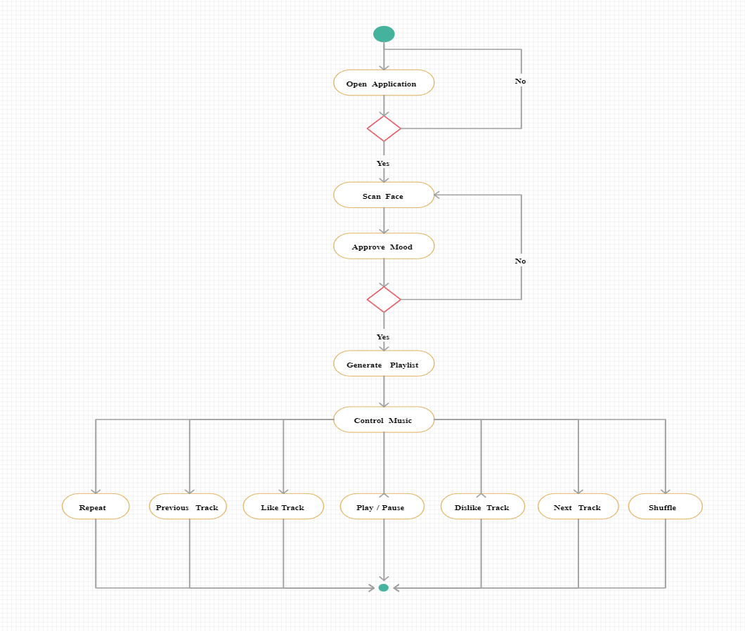

**Fig.4.5** Activity Diagram

**4.2.5 Collaboration Diagram**

In our collaboration diagram, method calls will be outlined with a number technique. The integer identifies methods as called chainly one after another. Listen to the given audio and practice speaking to fluently deliver the speech. We took the order management system, as a client-connecting layer, to show how requests and responses are received and sent by the various components of the collaboration group. The operation is much identical to that of an arrangement diagram. On the other hand, in cooperation diagram there is no object organization described but sequence diagram does it instead.

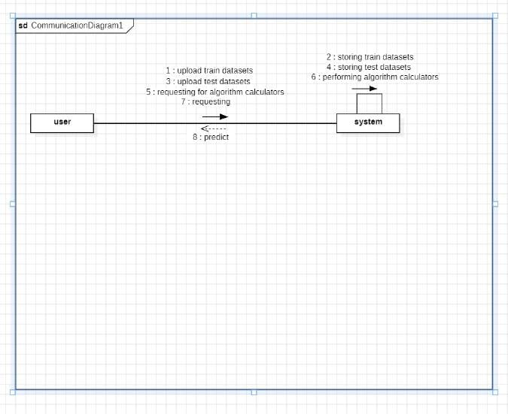

**Fig.4.6** Collaboration Diagram

**4.2.6 Component diagram**

The component diagrams are the manifestations of a system through its physical components. Such artifact contain files, executables, libraries, etc. Therefore, the purpose of this simplified diagram is different . The component diagrams serve an important purpose at the implementation level. On the other hand, the scenarios are developed after a long time to have a visualized implementation plan. At first, the system development involves building UML diagrams, and once the artifacts are finished, component diagrams are used for gaining insight into the implementation.

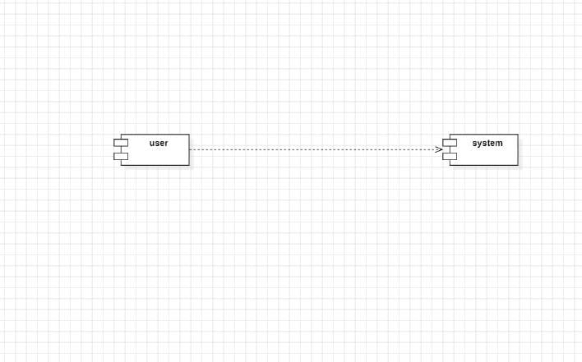

**Fig.4.7** Component Diagram

**4.2.7 Deployment Diagram**

A deployment diagram shows the deployment perspective of the system. It is related to the component diagram. Since the components are deployed according to the deployment diagram. deployment diagram consists of nodes. Nodes are physical hardware units needed by an application to install it.

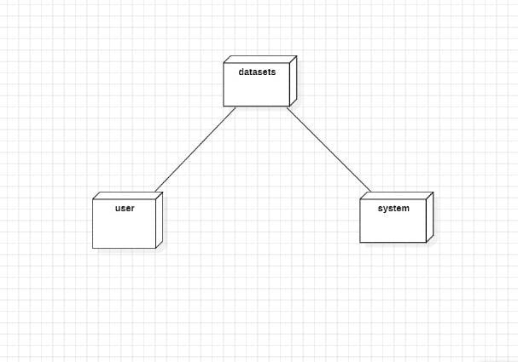

**Fig.4.8** Deployment Diagram

**4.3 Algorithms**

1. **Convolutional Neural Network (CNN)**: We were using Keras Sequential API to sequentially create layers beginning with the input.

The different types of layers typically involved in CNN are:

* + **Convolutional Layer (Conv2D):** A set of teachable traits. Here, filter application is thirty-two. The kernel filter is responsible for modifying an area from the picture in accordance to the size of the kernel. Filter maps are the edited pictures. The next paramount part of the network is the pooling layer that acts as a subsampling filter.
  + **Pooling Layer (Max pooling2D):** Picks up the pixel with the highest value between the left and right neighbors. In this level, the function is adopted to cut the bias and simultaneously reduce the overfitting to certain extent. Putting the two layers above together enables ANN to use local features as well as global features recognition..
  + **Activation Function (RELU):** The Network Activation Function (RELU) makes the network non-linear. We employ the Dropout regularization technique in which we randomly disregard (their weights are set to zero) a certain proportion of nodes in the layer for each training data sample. This helps us to generalize the network. We need to flatten the final feature maps to get just one 1D vector. Hence, we employ Flatten Layer.
  + **Flatten Layer:** After the previous layer a process called flatten connection layers can be completed. It unites all of the native detected variations derived from the previous convolutional layers
  + **Fully Connected Layer (Dense):** In the last layer, Dense ( )does the job of listing the net occurrence of each category. Once we have the layers in place, we must determine a scoring function, a loss function, and a suitable optimizing method. The binary cross entropy is the chosen function that calculates the error degree between the experimented and the expecting labels. Another crucial part is the optimizer after that. Unlike other optimizers, Adam Optimizer has the ability to integrate a functionality from other optimizers. Adam is an excellent and very commonly known method of learning models. The metric function estimates the system's ability using metric error. Another terminus is called the Learning Rate (LR).It's an annealing process. To decrease the amount of loss, it is advisable to reduce the Rate-Learning progressively. The Case of ReduceLROnPlateau: As the name implies, this is used to reduce the LR to achieve global minimum of the loss function.

1. **Haarcascade Algorithm**: It is rather an algorithm of machine learning to categorize objects in a photo consisting of. It is object detection that it is mainly aimed at. Cascade classifier is shown in various stages intake similar to weak learners. These are called weak classifiers which are also known as boosting. They are the simplest form of classifiers that have a name. If the tag reached a positive state, then it would pass to the next level displaying the result. The identifying system has a positive side and also a negative side where the images to be qualified according to the labels given. It involves the set of the positive images rather than negative images at all levels. More grainy images are prefered than the ones with higher resolution and better amount of grain. Above the line, we are going to apply the haarcascade frontal face_default.xml to find out the object in the image. A face is made of nose, eyes, mouth, ears function. Open cv include haar cascade that is designed to check frontal face. It can also extract the features from the object of its perception. It works by teaching the bad images over positive ones that create the conditioned reflex responses in the person. We want to feed our classifier with good images only which those it should classify. Contrary to that, the Negative Image consists of all the pictures, except those ones that have the object we are searching for.

**Chapter 5**

# CODING

## 5.1 Pseudo Code

import os

import cv2

import urllib

import numpy as np

from werkzeug.utils import secure_filename

from urllib.request import Request, urlopen

from flask import Flask, render_template, Response, request, redirect, flash, url_for

from camera import VideoCamera

from Graphical_Visualisation import Emotion_Analysis

app = Flask(__name__)

app.config['SEND_FILE_MAX_AGE_DEFAULT'] = 0

UPLOAD_FOLDER = 'static'

ALLOWED_EXTENSIONS = {'png', 'jpg', 'jpeg', 'gif'}

app.config['UPLOAD_FOLDER'] = UPLOAD_FOLDER

def gen(camera):

"" "Helps in Passing frames from Web Camera to server"""

while True:

frame = camera.get_frame()

yield (b'--frame\r\n'

b'Content-Type: image/jpeg\r\n\r\n' + frame +b'\r\n\r\n')

def allowed_file(filename):

return ('.' in filename and

filename.rsplit('.', 1)[1].lower() in ALLOWED_EXTENSIONS)

def mood(result):

if result=="Happy":

return 'Since you are happy, lets keep up the good mood with

some amazing music!'

elif result=="Sad":

return 'It seems that you are having a bad day, lets cheer you

up with some amazing music!'

elif result=="Disgust":

return 'It seems something has got you feeling disgusted. Lets improve your mood with some great music!'

elif result=="Neutral":

return 'It seems like a normal day. Lets turn it into a great

one with some amazing music!'

elif result=="Fear":

return 'You seem very scared. We are sure that some music will

help!'

elif result=="Angry":

return 'You seem angry. Listening to some music will surely help

you calm down!'

elif result=="Surprise":

return 'You seem surprised! Hopefully its some good news. Lets

celebrate it with some great music!'

def provide_url(result):

if result=="Happy":

return

'https://open.spotify.com/playlist/1BVPSd4dynzdlIWehjvkPj'

elif result=="Sad":

return 'https://www.writediary.com/ '

elif result=="Disgust":

return 'https://open.spotify.com'

elif result=="Neutral":

return 'https://www.netflix.com/'

elif result=="Fear":

return 'https://www.youtube.com/watch?v=KWt2-lUpg-E'

elif result=="Angry":

return 'https://www.onlinemeditation.org/'

elif result=="Surprise":

return

'https://www.google.com/search?q=hotels+near+me&oq=hotels+&aqs=chrome.1.69i57j0i433i457j0i402l2j0i433l4j0l2.3606j0j7&sourceid=chrome&ie=UTF-8'

def activities(result):

if result == "Happy":

return '• Try out some dance moves'

elif result == "Sad":

return '• Write in a journal'

elif result == "Disgust":

return '• Listen soothing music'

elif result == "Neutral":

return '• Watch your favourite movie'

elif result == "Fear":

return '• Get a good sleep'

elif result == "Angry":

return '• Do meditation'

elif result == "Surprise":

return '• Give yourself a treat' \

@app.route('/')

def Start():

return render_template('Start.html')

@app.route('/video_feed')

def video_feed():

return Response(gen(VideoCamera()),

mimetype='multipart/x-mixed-replace;

boundary=frame')

@app.route('/RealTime', methods=['POST'])

def RealTime():

return render_template('RealTime.html')

@app.route('/takeimage', methods=['POST'])

def takeimage():

v = VideoCamera()

_, frame = v.video.read()

save_to = "static/"

cv2.imwrite(save_to + "capture" + ".jpg", frame)

result = Emotion_Analysis("capture.jpg")

if len(result) == 1:

return render_template('NoDetection.html', orig=result[0])

sentence = mood(result[3])

activity = activities(result[3])

link = provide_url(result[3])

return render_template('Visual.html', orig=result[0], pred=result[1], bar=result[2], music=result[3],

sentence=sentence, activity=activity,

image=result[3], link=link)

@app.route('/ManualUpload', methods=['POST'])

def ManualUpload():

return render_template('ManualUpload.html')

@app.route('/uploadimage', methods=['POST'])

def uploadimage():

if request.method == 'POST':

if 'file' not in request.files:

flash('No file part')

return redirect(request.url)

file = request.files['file']

if file.filename == '':

flash('No selected file')

return redirect(request.url)

if file and allowed_file(file.filename):

filename = secure_filename(file.filename)

file.save(os.path.join(app.config['UPLOAD_FOLDER'],

filename))

result = Emotion_Analysis(filename)

if len(result) == 1:

return render_template('NoDetection.html', orig=result[0])

sentence = mood(result[3])

activity = activities(result[3])

link = provide_url(result[3])

return render_template('Visual.html', orig=result[0], pred=result[1], bar=result[2], music=result[3],

sentence=sentence, activity=activity,

image=result[3], link=link)

@app.route('/imageurl', methods=['POST'])

def imageurl():

url = request.form['url']

req = Request(url,

headers={'User-Agent': 'Mozilla/5.0'})

webpage = urlopen(req).read()

arr = np.asarray(bytearray(webpage), dtype=np.uint8)

img = cv2.imdecode(arr, -1)

save_to = "static/"

cv2.imwrite(save_to + "url.jpg", img)

result = Emotion_Analysis("url.jpg")

if len(result) == 1:

return render_template('NoDetection.html', orig=result[0])

sentence = mood(result[3])

activity = activities(result[3])

link = provide_url(result[3])

return render_template('Visual.html', orig=result[0], pred=result[1], bar=result[2], music=result[3],

sentence=sentence, activity=activity, image=result[3], link=link)

if __name__ == '__main__':

app.run(debug=True)

**Chapter 6**

# IMPLEMENTATION and RESULTS

# 6.1 EXPLANATION OF KEY FUNCTIONS

# Facial Expression Detection Functions:

# Function to capture facial expressions using the inbuilt camera.

# Preprocessing function to prepare the captured images for emotion detection.

# Emotion detection function using a Convolutional Neural Network (CNN).

# Function to extract features from the input face images.

# Music Recommendation Functions:

# Function to retrieve music tracks based on detected emotions.

# Algorithm for generating music playlists dynamically.

# Integration with Pygame for audio playback.

# User Interface Functions:

# Functions to create the graphical user interface using Tkinter.

# Interface functions for displaying captured facial expressions and recommended music playlists.

# Functions to handle user interactions such as starting, stopping, or skipping tracks.

# Testing and Evaluation Functions:

# Functions to split the dataset into training and testing sets.

# Evaluation functions to measure the performance of the emotion detection model.

# Functions to calculate metrics such as accuracy, precision, recall, and F1 score.

# Integration and System Control Functions:

# Functions to coordinate the flow of data between different modules.

# Error handling functions to ensure smooth operation of the system.

# Integration functions to combine facial expression detection, music recommendation, and user interface functionalities seamlessly.

# Optimization and Performance Improvement Functions:

# Functions to optimize computational efficiency, such as parallelization or algorithmic optimizations.

# Functions to fine-tune the emotion detection model for better accuracy.

## Functions to handle real-time processing efficiently.

## Method of Implementation

## Face Detection

Face recognition is one of the applications under group of technologies computer vision. This is a procedure that is used to produce algorithms and train them to locate faces or objects in pictures for instance using object detection or one of the related methods. The automated detection can happen in real time by using any of the video frames or photos. Through the use of classifiers; these are algorithms that can either label an image as containing a face (1) or not having a face (0). Trainer for classifiers distinguishes people by a variety of images to cultivate precision. OpenCV employs two types of classifiers: LBP (Local Binary Patterns) and Haar Cascades. A Haar feature-based classifier is applied for the face detection. The training dataset comprises fixed variable face data for precise detection faces. The leading target of face detection is to find and separate faces from other patterns of noise and different objects. It is a learning machine powered approach that learns cascade function using a set of input file. It is done with the help of a Haar Wavelet approach to split the pixels inside an image into boxes based on the square. Here, this method makes it possible to become highly accurate from data referred to as "training data".

1. **Feature Extraction**

As a part of the action, we assume the pre-trained sequential network as an indifferent extractor. Letting the fed image go forward and stop at the layer, which we have input as a value, so as to obtain our features. The first convolutional layer finds the features of the image with high level but it is successful with just a few kernels. The deeper we go in the layers machine, the number of filters grows by the factor of two or even three the amounts of filters in the previous layer. Filters in deeper layers going further pick up more features but at the same time their use has significant computational burden. For this purpose, we employed the CNN algorithm with its robustness, for detection and distinction. The problem functions will be processed into feature maps which are final outputs of all layers after the first layer in the architecture. Suppose the image we need to analyze is already loaded and we proceed to determine the feature map from it to the areas in the image we would like to focus on while tackling the classification task. The Convolution layer operate with filtering or a Feature Detectors on the input image or for the output of the previous feature map layer. Feature map visualization of convolutional network shows the structure of each unit in each of Convolutional layers of model.

1. **Emotion Detection**

Convolutional neural network architecture. Convolution network architecture is responsible for applying filters or feature detectors on the input picture to result in the creation of feature maps or activation maps using the Relu activation function. The edges, vertical or horizontal lines, bends, which are in the picture can be identified by feature detectors or filters. Finally, the pooling of the feature maps is done to uphold invariance. Pools assume that if we change the level of input by a given amount, the pooled outputs will remain invariable. We may user any of the pooling options, such as min, average, and max. Nevertheless, the max-pooling accomplishes better than the min or average pooling. The last operation is flattening all of the inputs and feeding them into the deep neural network, providing outputs for the object's classification. The picture will be assigned as the binary or multi-class task for the purpose of recognizing numbers or splitting distinct clothes items. NN act like black boxes operating with internal features which cannot be explained. Thus, we give the input image as an input and the model generates the outcome. Emotion detection is accomplished by a model that has been loaded with weights, which were trained using CNN. When the real photo derived from the user is transmitted to the pre-trained CNN model, the latter predicts the emotion and places the label afterward.

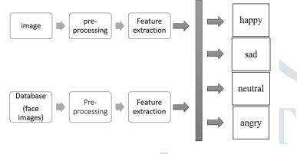

**Fig.6.1** Emotion Detection

1. **Music Recommendation**

Songs Database This database of Bollywood Hindi music. It has up to about 150 songs per emotion. Everybody is aware of that music is vital in setting our moods. Therefore, if an individual is angry, an algorithm will provide a music playlist which initiates a process that will eventually lead to the user feeling better. Music Playlist Recommendation The module also identifies user's emotion in real time. With this, the different labels such as Happy, Sad, Angry, Surprise, and Neutral are assigned. Next we used the os.listdir() method in Python, which related the folder labels to the music database that we had generated in organized folders. Tab.1 is a list of songs. Such os.listdir() functionality lists down all files contained in the specified directory. If label is 'Happy': os.chdir("C:/Users/deepali/Downloads/Happy") self.mood.set( "You are looking happy, have a song for you" ) Loading Songs # Adding Songs to playlist for Track in songtracks: self.playlist.insert (END, track) This will result in a suggested music list on the music player's GUI after the algorithm has determined user mood For playing the audio, we used Pygame library, which support not only audio but also video format. Use functions of this library, such as playsong, pausesong, resumesong, and stopsong for the interaction with music player. Such parameters as playlist, songstatus, and root are employed to keep the names of all songs, current status and the main GUI panel displayed, respectively. For the GUI we went with the Tkinter package.

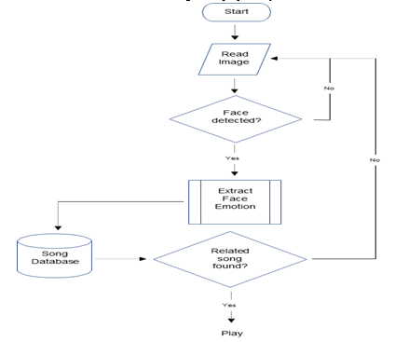

**Fig.6.2** Music Recommendation

## 6.2.1 OUTPUT SCREENS :

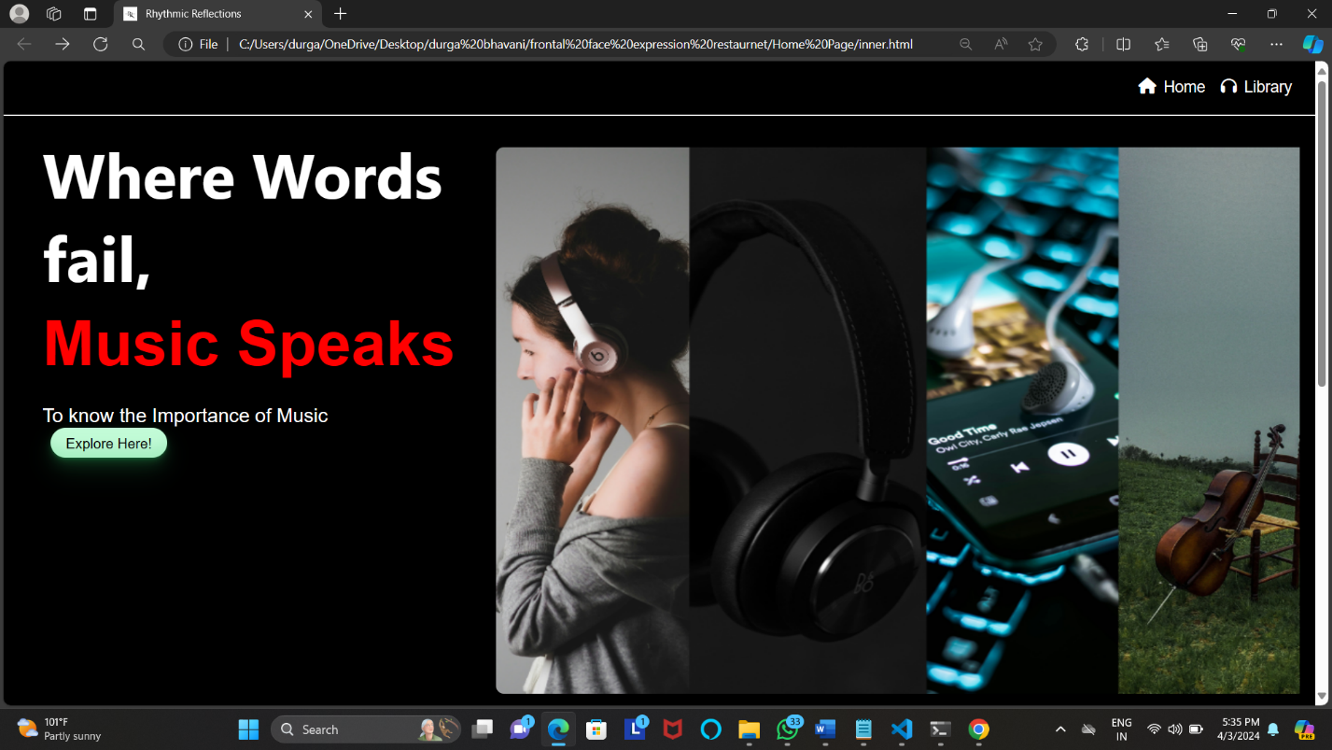

**Fig.6.3** Home Page

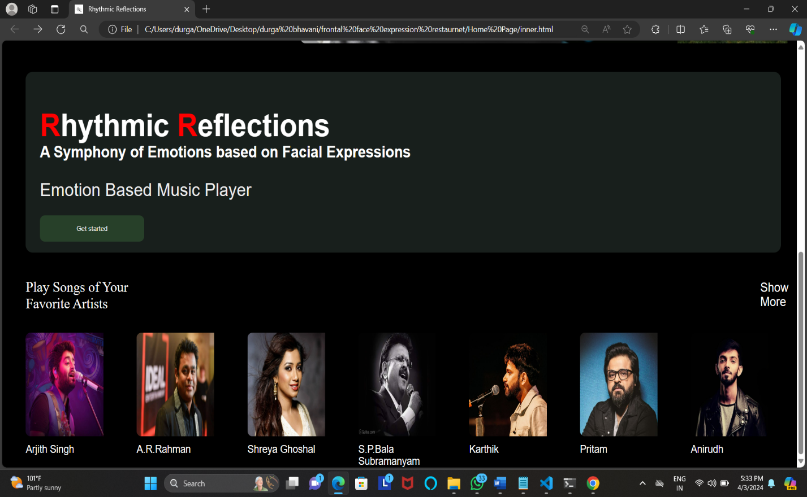

**Fig.6.4** Music Playlist Page

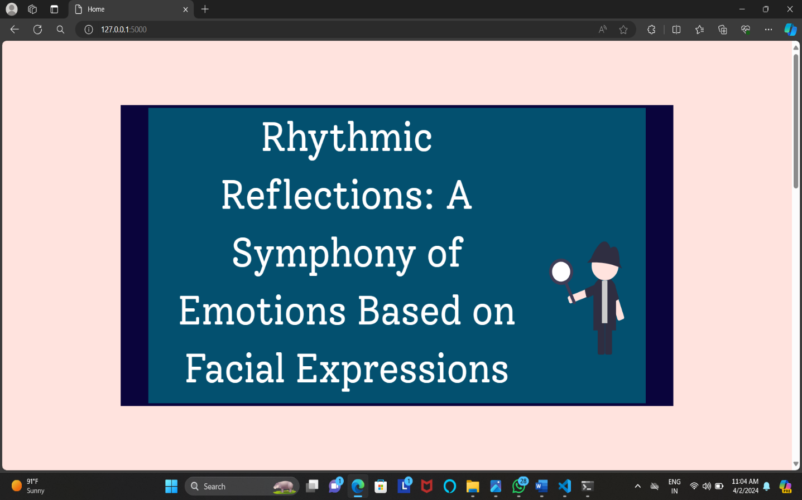

**Fig.6.5** Emotion Detection Home Page

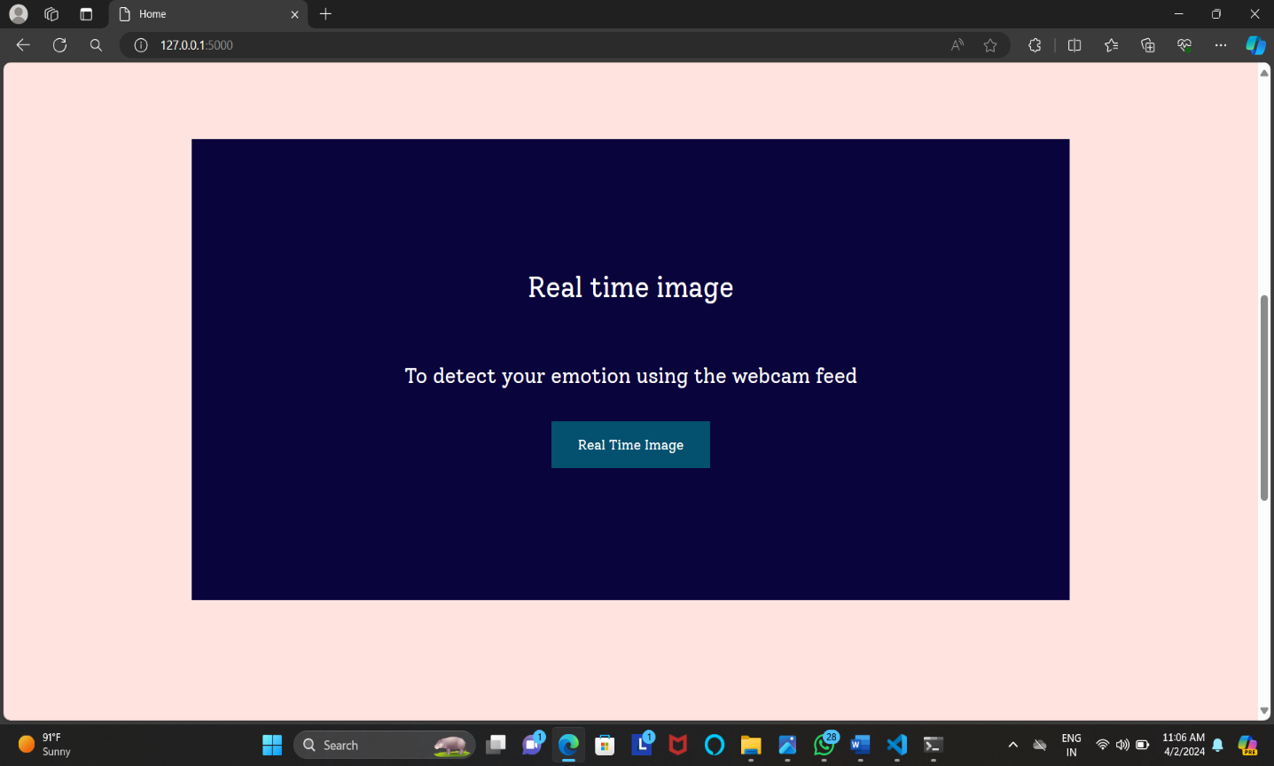

**Fig.6.6** Real Time Image Detection

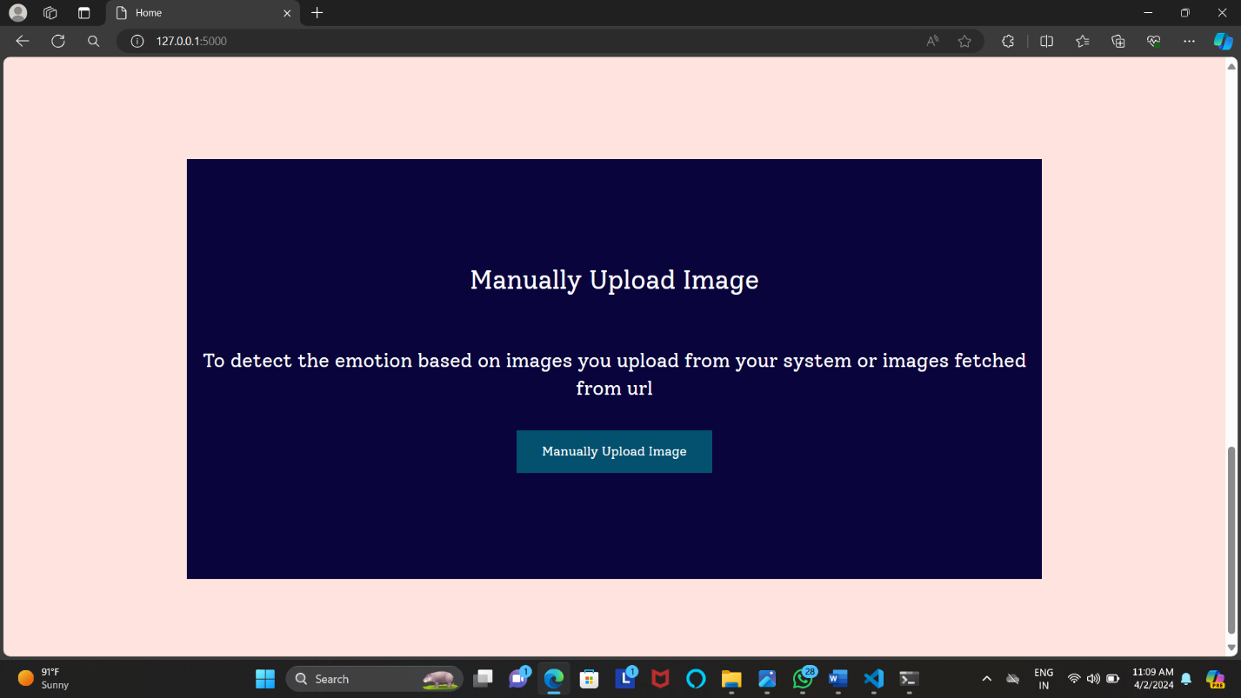

**Fig.6.7** Manual Image Detection

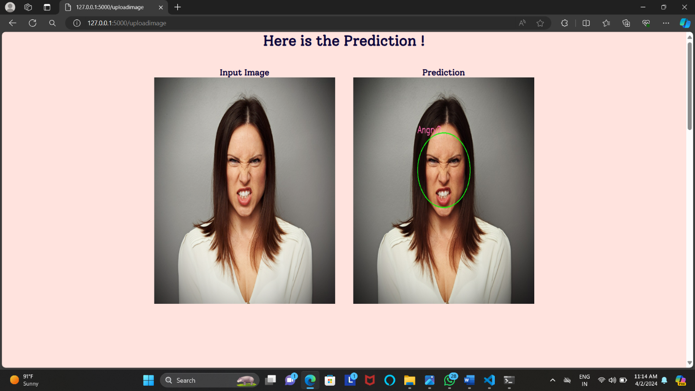

**Fig.6.8** Manual Image Prediction

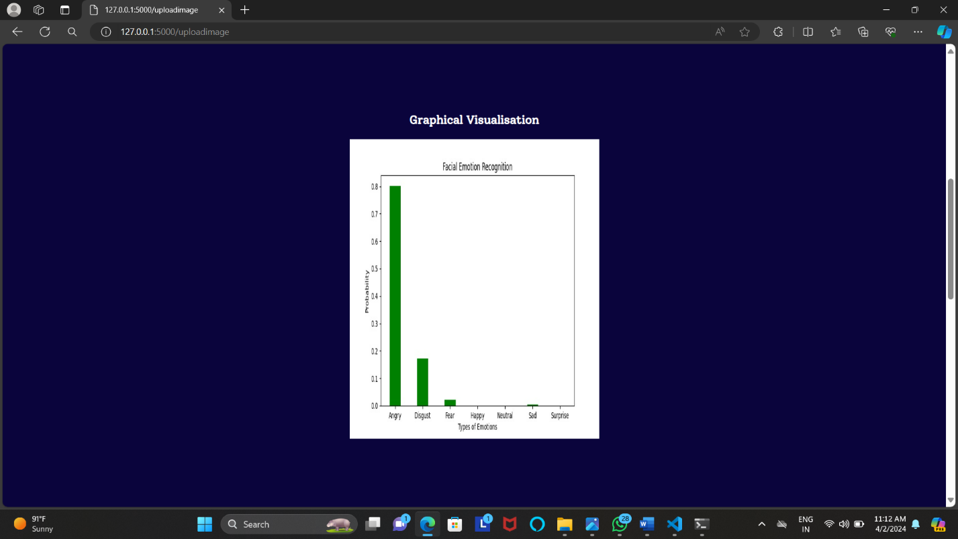

**Fig.6.9** Graphical Visualization for Manual Image

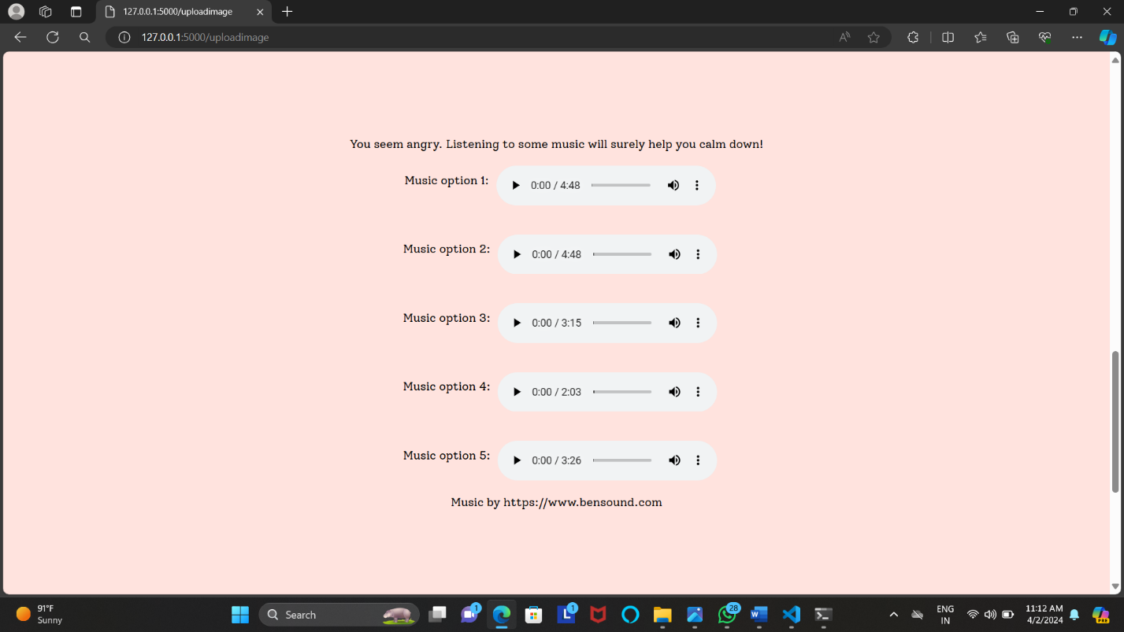

**Fig.6.10** Song Recommendation for Angry Emotion

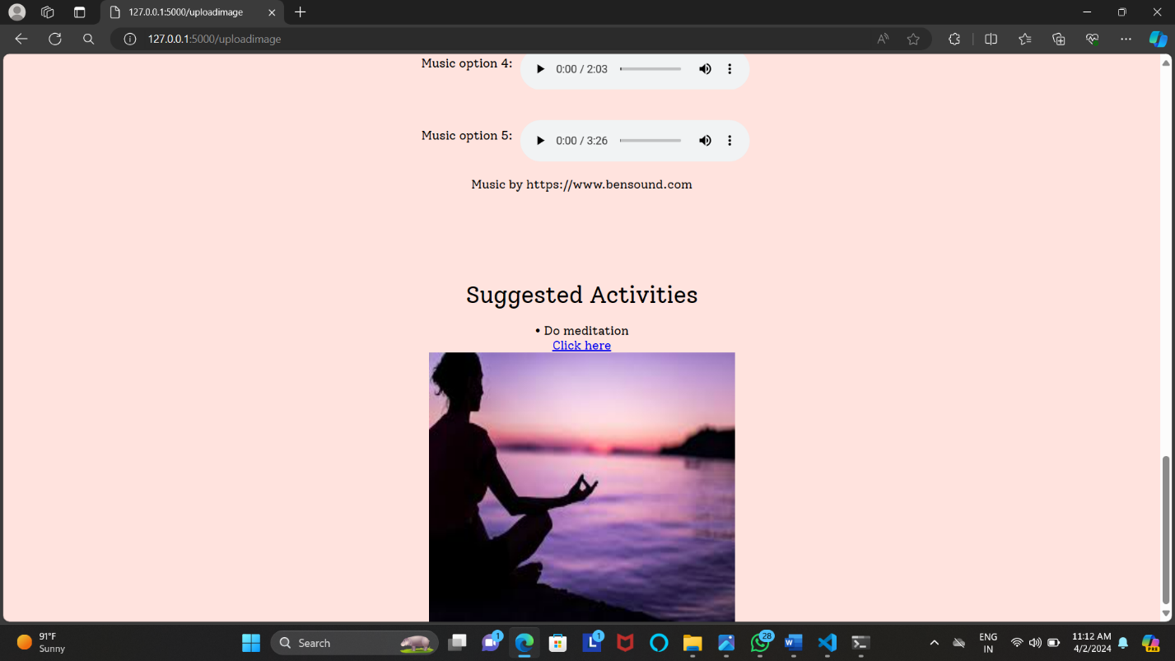

**Fig.6.11** Suggested Activities to Angry Emotion

## RESULT ANALYSIS:

## Emotion detection accuracy considers precision, recall, and F1 scores for each emotion category.

## User experience collects feedback on ease of use and satisfaction.

## Emotional measures to measure their effectiveness through expert judgment.

## The effect of sound systems is investigated by the perceived emotion of pace.

## When comparing a baseline to performance, it considers an existing system.

## Future directions discuss possible growth and expansion.

**Chapter 7**

# TESTING and VALIDATION

## 7.1 Design of Test Cases and Scenarios

## 

|  |  |  |
| --- | --- | --- |
| **Images** | **Expressions** | **Testing result** |
|  | **Angry** | **Positive** |
|  | **Sad** | **Positive** |
|  | **Neutral** | **Positive** |
|  | **Disgust** | **Positive** |
|  | **Happy** | **Positive** |
|  | **Fear** | **Positive** |
|  | **surprise** | **Positive** |

**Table 7.1** The Testing Results for Different Expressions

## Validation

## Validation ensures that a product, system, or service meets specified requirements and satisfies stakeholder needs. In software development, validation ensures correct and effective functionality, delivering intended features to users. Validation involves testing, verification, and evaluation to confirm compliance with quality standards, regulatory requirements, and user expectations.

## Functional Testing: Validate the correct functioning of facial expression detection, emotion recognition, and music recommendation features individually and in combination.

## Usability Testing: Gather user feedback on the ease of using facial expressions to interact with the system and the satisfaction with the recommended music choices.

## Accuracy Testing: Validate the accuracy of emotion recognition and the relevance of music recommendations based on detected facial expressions.

## Integration Testing: Ensure seamless interaction between facial expression detection, emotion recognition, and music recommendation modules.

## Performance Testing: Evaluate system responsiveness for facial expression detection and music recommendation tasks under various conditions.

## Security Testing: Assess data protection measures to safeguard user facial data and ensure compliance with privacy regulations.

## End-to-end Testing: Validate the entire user journey from facial expression input to music recommendation to ensure a smooth and uninterrupted user experience

**Chapter 8**

# CONCLUSION and FUTURE SCOPE

# 8.1 Conclusion

That project implements music recommending system by the usage of the user's emotions, which are collected from the pictures taken in real-time. This project is designed to improve the interaction between music system and user because while for some, music is something that helps change the mood, other people may find that it works great as a stress reliever. The implementation of the aforementioned developments exhibits the emergence of a music selection system which is strongly related to one's emotions. As a result, the current system shows a face-based recognition system that has the power of choosing the music to be played via what the emotions of a person can be detected.

**8.2 Future Scope**

The musical instrument we use is locally usable and nowadays everything has become portable and efficient, but it would be possible to capture a person's emotions with various portable sensors and easy to use instead of the whole manual. using GSR (galvanic skin response) and PPG (plethysmography physiological, which would give us enough information to accurately predict the mood of the client. This advanced system can benefit and a system with advanced functions that must be constantly updated Methodology that improves the automatic reproduction. of songs, occurs through recognition Facial expressions are recognized through a local machine program interface, an alternative method based on foreign emotions excluded from our system.

# REFERENCES

1. Raut, Nitisha, \\\"Facial Emotion Recognition Using Machine Learning\\\" (2018). Master\\\'s Projects. 632. <https://doi.org/10.31979/etd.w5fs-s8wd>.
2. Hemanth P,Adarsh ,Aswani C.B, Ajith P, Veena A Kumar, “EMO PLAYER: Emotion Based Music Player”, International Research Journal of Engineering and Technology (IRJET), vol. 5, no. 4, April 2018, pp. 4822-87.
3. Music Recommendation System: “Sound Tree”, Dcengo Unchained: S?la KAYA, BSc.; Duygu KABAKCI, BSc.; I??nsu KATIRCIO?LU, BSc. and Koray KOCAKAYA BSc. Assistant : Dilek Önal Supervisors: Prof. Dr. ?smail Hakk? Toroslu, Prof. Dr. Veysi ??ler Sponsor Company: ARGEDOR.
4. Tim Spittle, lucyd, GitHub, , April 16, 2020. Accessed on: [Online], Available at: <https://github.com/timspit/lucyd>
5. Abdul, J. Chen, H.-Y. Liao, and S.-H. Chang, “An Emotion-Aware Personalized Music Recommendation System Using a Convolutional Neural Networks Approach,” Applied Sciences, vol. 8, no. 7, p. 1103, Jul. 2018.
6. Manas Sambare, FER2013 Dataset, Kaggle, July 19, 2020. Accessed on: September 9, 2020. [Online], Avalilable at: <https://www.kaggle.com/msambare/fer2013> .
7. MahmoudiMA, MMA Facial Expression Dataset, Kaggle, June 6, 2020. Accessed on: September 15, 2020. [Online], Available at: <https://www.kaggle.com/mahmoudima/mma-facial-expression>.
8. Dr. Shaik Asif Hussain and Ahlam Salim Abdallah Al Balushi, “A real time face emotion classification and recognition using deep learning model”, 2020 Journal. of Phys.: Conf. Ser. 1432 012087 .
9. P. Lucey, J. F. Cohn, T. Kanade, J. Saragih, Z. Ambadar and I. Matthews, \\\"The Extended Cohn-Kanade Dataset (CK+): A complete dataset for action unit and emotion-specified expression,\\\" 2010 IEEE Computer Society Conference on Computer Vision and Pattern Recognition - Workshops, San Francisco, CA, USA, 2010, pp. 94-101, doi: 10.1109/CVPRW.2010.5543262.
10. Puri, Raghav & Gupta, Archit & Sikri, Manas & Tiwari, Mohit & Pathak, Nitish & Goel, Shivendra. (2020). Emotion Detection using Image Processing in Python.
11. Lee, J., Yoon, K., Jang, D., Jang, S., Shin, S., & Kim, J. (2018). MUSIC RECOMMENDATION SYSTEM BASED ON GENRE DISTANCE AND USER PREFERENCE CLASSIFICATION.
12. Kaufman Jaime C., University of North Florida, “A Hybrid Approach to Music Recommendation: Exploiting Collaborative Music Tags and Acoustic Features”, UNF Digital Commons, 2014.
13. D Priya, Face Detection, Recognition and Emotion Detection in 8 lines of code!, towards data science, April 3, 2019. Accessed on: July 12, 2020 [Online], Available at: https://towardsdatascience.com/facedetection-recognition-and-emotion-detection-in-8-lines-of-codeb2ce32d4d5de .
14. bluepi, “\\\\Classifying Different Types of Recommender Systems, November 14, 2015. Accessed on: July 7, 2020. [Online], Availableon:https://www.bluepiit.com/blog/classifying-recommendersystems/#:~:text=There%20are%20majorly%20six%20types,system %20and%20Hybrid%20recommender%20system.